Endourological Society 2020 Summer Studentship – Project Summary
Student: Tiange Li¹
Supervisor: Dr. Monica Farcas^{1,2}
¹Faculty of Medicine, University of Toronto, Toronto, ON
²Department of Urology, St. Michael’s Hospital, Toronto, ON

Advanced Uroflowmetry Device
Introduction
Benign Prostatic Hyperplasia (BPH) is one of the most common diseases of aging men^{1,2}, and represents a significant detriment to men’s health and wellbeing, as well as a considerable burden on healthcare costs³. Worldwide, BPH affects 1 in 4 men at some point in their life², and is a chronic progressive condition that worsens inexorably with age^{1,4}. Indeed, 50% of men in their 50s-60s, and up to 90% of men in their 70s-80s report experiencing symptoms of BPH^{3,5,6}. BPH affects 38.1 million patients in the US alone, and consumes $4 billion USD annually in direct and indirect costs^{1,7}. These figures will only increase with the aging of the population⁸.
BPH most commonly results in bothersome lower urinary tract symptoms (LUTS), a spectrum of concerns that are profoundly distressful to patients and detrimental to their quality of life^{9,10}. Despite its clear clinical and systems level significance, BPH remains underdiagnosed and undertreated¹⁰. Only 1/3 of patients with bothersome LUTS were even aware of the medical or surgical interventions available, and even fewer sought treatment^{1,11}. As LUTS is primarily characterized by the “bothersomeness” of its symptoms, it has been suggested that many men simply tolerate and accept their symptoms as a consequence of aging¹⁰, in spite of recent advancements in management options^{1,10,12}. This suggests a need for increased education and awareness of BPH and its management, as well as improved, more efficient clinical tools for its screening and diagnosis.

Background
The process of diagnosing BPH is typically initiated with uroflowmetry, a non-invasive bedside test that records urinary volume and flowrate while patients void into a measurement device. The results of this ubiquitous test help inform clinical decision making, such as the initiation of life-long medical therapy, further investigations with more invasive methods (e.g. cystoscopy, urodynamic testing), or surgery.
The International Continence Society (ICS) has made several recommendations on good uroflowmetric practice to improve the quality of testing and data¹³. In particular, uroflowmetry should be conducted with patients in their preferred voiding position, when they feel a “normal” desire to void, and with minimal anxiety and physical discomfort. The process of uroflowmetry must, in essence, be representative of a patient’s normal voiding experience.
Existing uroflowmetric technology (Fig. 1) has remained stagnant for many decades. These are typically gravimetric systems, which measure urinary volume and flowrate as patients void into a weight-sensor enabled collection vessel. The vessels require manual cleaning after each use, which is unsanitary and messy, and often leads to time-consuming interruptions in workflow for urologists during already busy clinics. This further evolves into long wait times for patients, who must subsequently take the test in an unfamiliar voiding environment, using a device that is uncomfortable and not representative of the patient’s natural voiding habits. It is thus conceivable that patients’ true voiding data are not beingly appropriately captured.
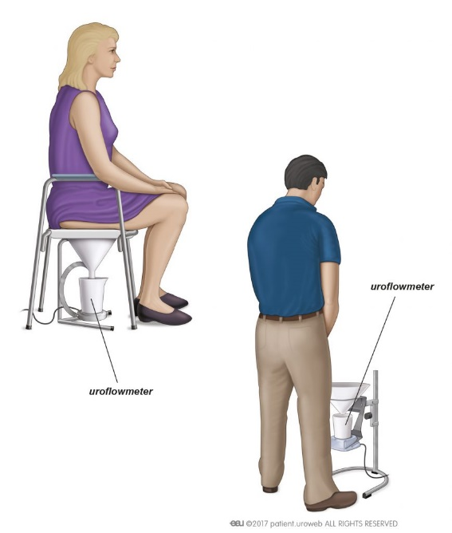
Figure 1: Gravimetric Uroflowmetry (https://patients.uroweb.org/wp-content/uploads/2018/12/Uroflowmetry-869x1024.jpg)

Methods and Results
Summary
We developed a novel uroflowmeter that significantly improves the efficiency and patient experience of uroflowmetry testing. Our device simply clips onto any standard toilet, turning uroflowmetry into a regular trip to the bathroom (Fig. 2). The device is unintrusive, and helps maintain a voiding environment that closely mimics a patient’s natural habits. The uroflowmetry process is less stressful and more comfortable for patients, while improving efficiency and workflow for clinicians.

Design Principles
Conventional, gravimetric uroflowmetry is typically carried out in clinic exam rooms, which pose an unfamiliar and uncomfortable voiding environment for patients. Additionally, the need for a clinician to manually empty and clean the device after each use creates a significant interruption that has typically been the rate-limiting step of conventional uroflowmetry.
Our primary goal was therefore the relocation of uroflowmetry away from clinic rooms and into standard bathrooms. We achieved this by creating a toilet-attached, flow-through uroflowmeter that measures urinary metrics as patients void directly into the toilet. After each use, urine can be simply flushed away, and the device is immediately ready for the next patient without the need for additional manual cleaning.
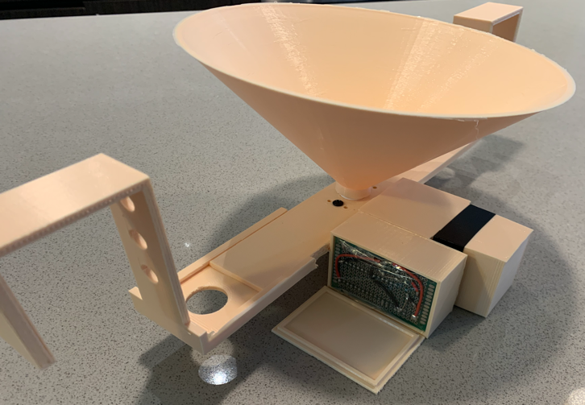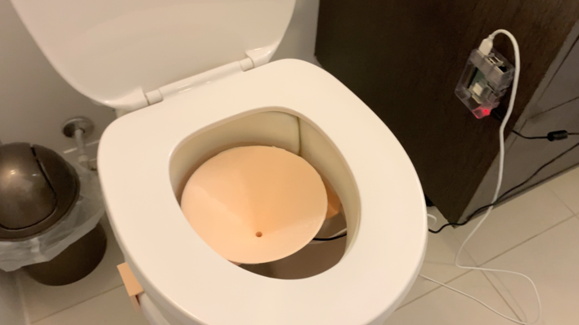
Figure 2: (left) assembled uroflowmeter. (right) toilet-attached uroflowmeter

Flow-Through Fluid Sensing
Central to our design are two solid-state MEMS (Micro-Electro-Mechanical System) liquid flow sensors. As urine passes through the sensor, flow is detected and measured using a thermal mass-flow principle, a technique that has faster response and increased accuracy compared to other flow sensor types¹⁴. These sensors have no moving, mechanical components, making them easy to clean, and eliminate points of failure such as mechanical wear-down, obstruction to flow, and risk of clogging compared to more common fluid sensors (e.g. turbine type).

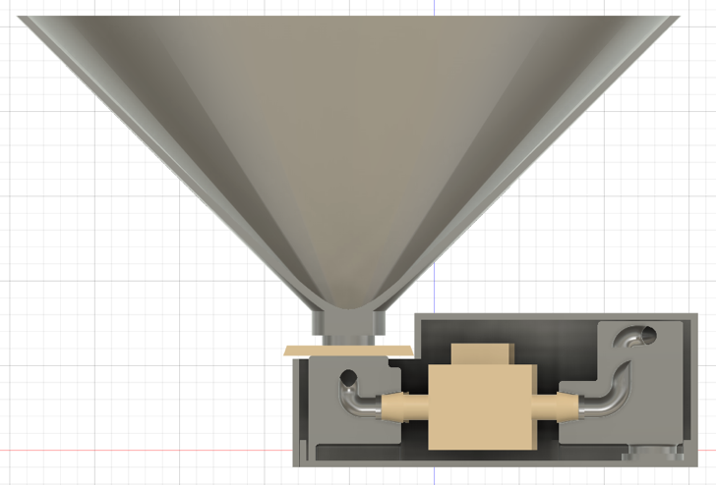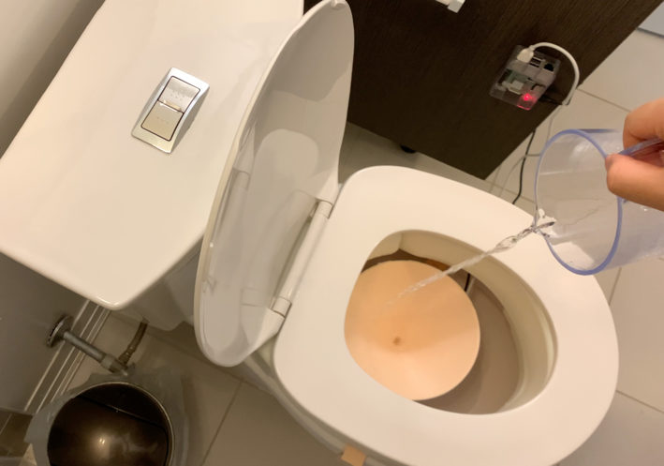
Figure 3: (left) flow-through design. (right) simulating a patient void – uroflowmetry is performed while patients void normally into the toilet. Voiding metrics is measured in real-time while urine passes through the device and into the toilet. After each test, urine is simply flushed away, and the device is immediately ready for the next patient. No cleaning or other clinician maintenance is required, and patients are able to void in more familiar, comfortable environments.

Mechanical Design
The flow sensors and supporting electronics are integrated into a custom mechanical enclosure (Fig. 3) and plumbing system that enables: 1) an input funnel that collects voided urine from the patient, 2) internal plumbing that directs urine to the flow sensors, 3) an output that expels measured urine into the toilet, and 4) an adapter system that enables easily adjustable attachment to any standard toilet bowl. The plumbing system is capable of handling both high (25mL/s) and low (1mL/s) flowrates.
Electronics and Software
The MEMs sensors are supported by a 32-bit Teensy 3.2 microcontroller (PJRC, Portland, OR, USA), which helps perform raw data acquisition and initial processing. The Teensy’s small form factor, computing power, ease-of-programming, and low cost make it ideal for our application. The sensors and microcontroller are integrated on a custom, 5v voltage regulated circuit.
The sensors output an analog signal that is proportional to the flowrate of fluid passing through at any moment. We wrote custom firmware to record these raw data at a 400 Hz sampling rate on the Teensy microcontroller. We subsequently apply a simple averaging filter on these data, and send a 100 Hz resultant signal, via Serial communication, to an external Raspberry Pi miniature computer.
We wrote custom Python software for signal processing and data output on the Raspberry Pi. The Pi continuously reads microcontroller data from its Serial buffer, until it encounters signals above a pre-set threshold – indicating the start of a void. It next reads and records voiding data until flow has stopped for a specific amount of time (e.g. 60 seconds) – indicating the end of a void. This procedure ensures that any mid-void pauses, intermittency, or post-void dribbling, are appropriately captured as a single void.
Subsequently, the data is passed through a low-pass Butterworth filter to eliminate erroneous outliers. Using pre-calibrated, sensor-specific conversion equations, we then translate the raw analog voltages into usable flowrate data. Finally, the Pi performs a series of analyses on the data in order to obtain important clinic metrics (i.e. average and max flowrate and volume, number of voiding intervals, voiding and flow time, etc.), and sends these data to be printed for urologist interpretation and patient charts. An example output is shown in Fig. 4.

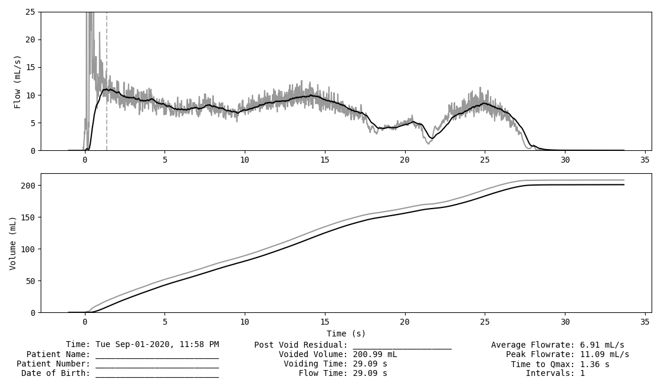
Figure 4: An example printout from our uroflowmeter prototype, showing flowrate curve (top), voided volume curve (middle), and clinically relevant metrics (bottom)

Future Work
In preliminary testing, our prototypes were accurate for voided volume (obtained via the time integral of flowrate data) to +/- 5% of the true value. Further sensor calibration and device optimization will be carried out to improve this value to ICS recommendations¹⁵ (+/- the greater of 2mL or 3%). Additionally, more formal in-vitro testing will be required in order to compare our device to conventional uroflowmeters, with respect to clinically relevant metrics. We aim to accomplish this by using calibrated precision-pumps to generate artificial fluid flow that mimics different patterns of urinary voiding.
Following in-vitro tests and any resultant refinements to the device, we will proceed to clinical trial testing. The purpose of this study will be two-fold. First, we aim to establish that our uroflowmeter performs as well as the incumbent gravimetric devices with respect to recording real flow data in real patients. Secondly, we must ensure that our primary value propositions with respect to patient comfort, accessibility, wait times, and clinic workflow are real and significant. We will thus conduct usability studies with both physicians and patients, and we expect increases in clinic efficiency, reductions in workflow interruption, lower patient wait times, as well as overall increased ease of use, patient satisfaction, and screening accuracy.
In future iterations, we also aim to add additional tests of value to the standard uroflowmeter, such as the detection of red blood cells, nitrites, and pH (as indications for cystoscopy, or further workup for infection or kidney stone disease).

References
1. Vuichoud, C. & Loughlin, K. R. Benign prostatic hyperplasia: Epidemiology, economics and evaluation. Can. J. Urol. 22, 1–6 (2015).
2. Lee, S. W. H., Chan, E. M. C. & Lai, Y. K. The global burden of lower urinary tract symptoms suggestive of benign prostatic hyperplasia: A systematic review and meta-analysis. Sci. Rep. (2017) doi:10.1038/s41598-017-06628-8.
3. Chughtai, B. et al. Benign prostatic hyperplasia. Nat. Rev. Dis. Prim. 2, 1–15 (2016).
4. Sundaram, D. et al. Correlation of prostate gland size and uroflowmetry in patients with lower urinary tract symptoms. J. Clin. Diagnostic Res. 11, AC01–AC04 (2017).
5. Zhang, W. et al. Prevalence of lower urinary tract symptoms suggestive of benign prostatic hyperplasia (LUTS/BPH) in China: Results from the China Health and Retirement Longitudinal Study. BMJ Open 9, 1–7 (2019).
6. Rawson, N. S. B. & Saad, F. The aging male population and medical care for benign prostatic hyperplasia in Canada. J. Can. Urol. Assoc. 4, 123–127 (2010).
7. Webb, J. C. et al. Value-based care for the treatment and evaluation of benign prostatic hyperplasia: an analysis of a metropolitan service area claims database. World J. Urol. (2020) doi:10.1007/s00345-020-03109-y.
8. Parsons, J. K. et al. Progression of Lower Urinary Tract Symptoms in Older Men: A Community Based Study. J. Urol. 183, 1915–1920 (2010).
9. Lim, K. Bin. Epidemiology of clinical benign prostatic hyperplasia. Asian J. Urol. 4, 148–151 (2017).
10. Speakman, M., Kirby, R., Doyle, S. & Ioannou, C. Burden of male lower urinary tract symptoms (LUTS) suggestive of benign prostatic hyperplasia (BPH) - Focus on the UK. BJU Int. 115, 508–519 (2015).
11. Rosen, R. et al. Lower Urinary Tract Symptoms and Male Sexual Dysfunction: The Multinational Survey of the Aging Male (MSAM-7). Eur. Urol. 44, 637–649 (2003).
12. Sayani, A. et al. Cost analysis of fixed-dose combination of dutasteride and tamsulosin compared with concomitant dutasteride and tamsulosin monotherapy in patients with benign prostatic hyperplasia in Canada. J. Can. Urol. Assoc. 8, 1–7 (2014).
13. Gammie, A. & Drake, M. J. The fundamentals of uroflowmetry practice, based on International Continence Society good urodynamic practices recommendations. Neurourol. Urodyn. 37, S44–S49 (2018).
14. Vraanes, M. & Lee, S. Thermal Mass Flow Sensors for Gas and Liquid Applications. Retrieved from https//www.idt.com/us/en/document/whp/whitepaper-mems-mass-flow-sensor 1–5 (2017).
15. Gammie, A. et al. International Continence Society Guidelines on Urodynamic Equipment Performance. Neurourol. Urodyn. 33(4), 370–379 (2014).

